- Home

Page -
Lauren Sisco
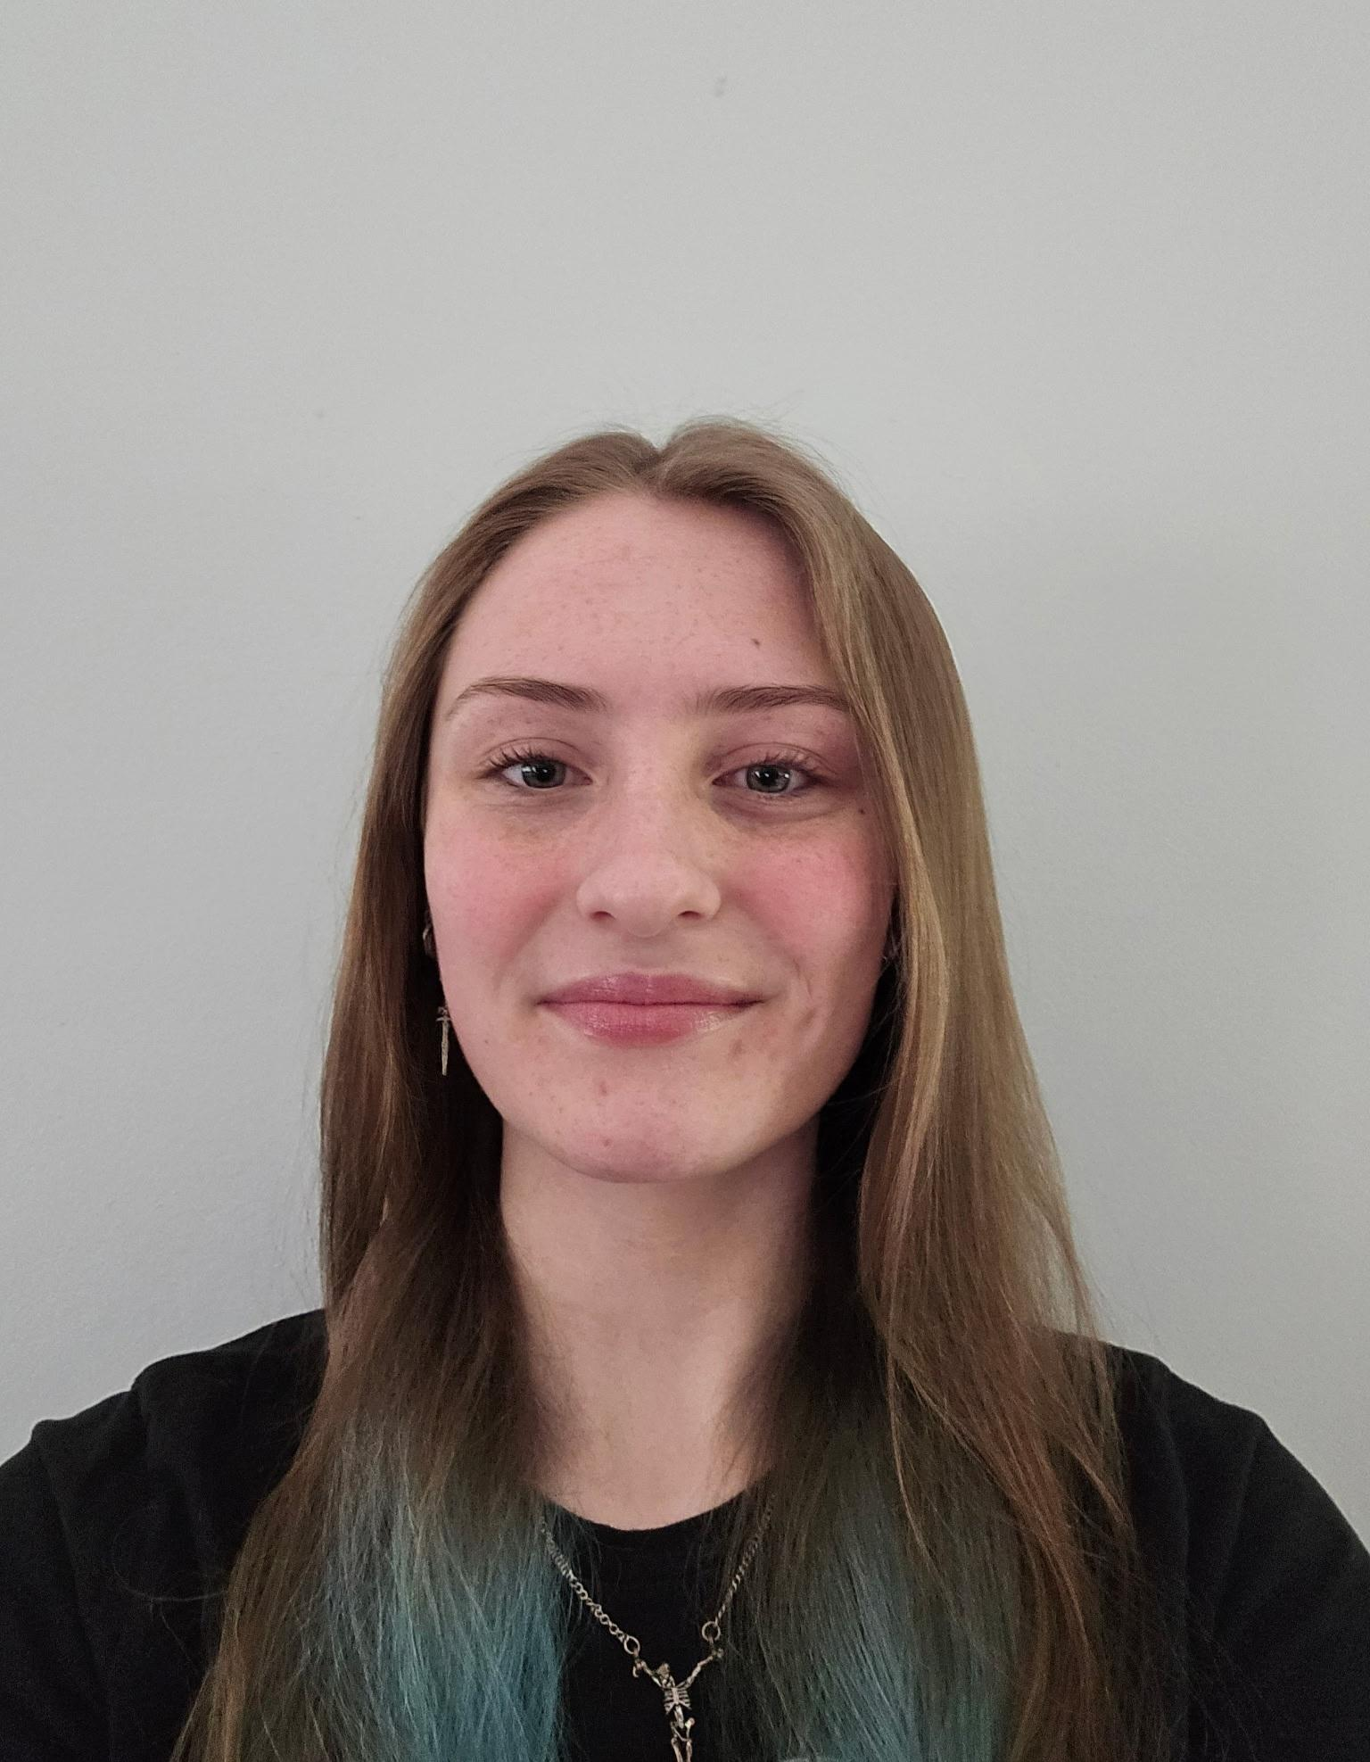
Age: 19 years old
Degree Plans:
- Majors: Accounting and Finance
- Minor: Economics
WELCOME VIDEO:
**Insert Welcome Video Here**

Hobby # 1
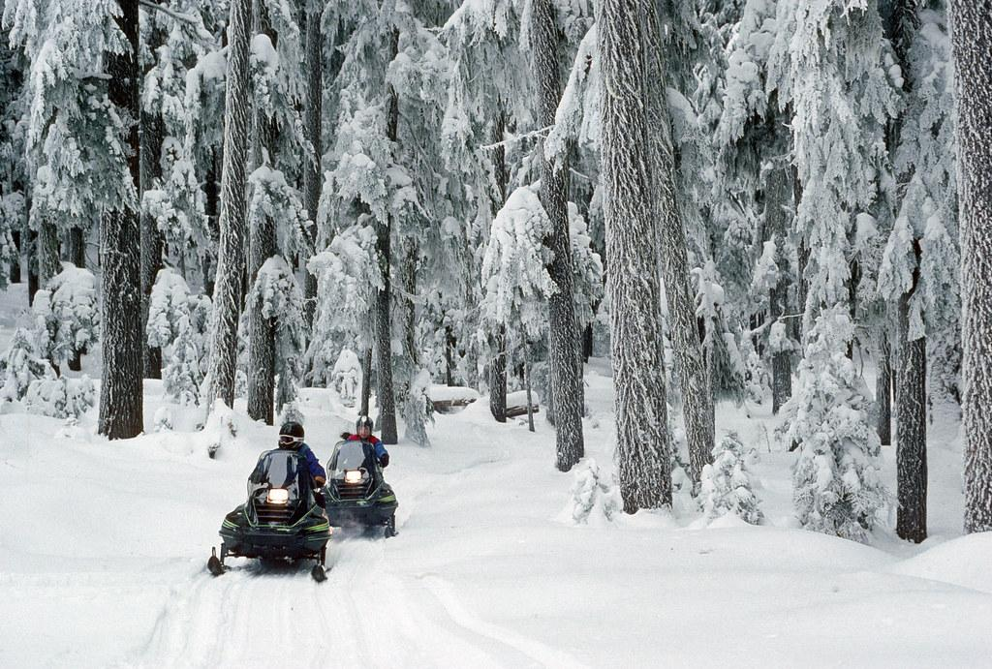
The first hobby I will be mentioning is snowmobiling. I enjoy the snow, driving, and making memories with my family - which is a mix of the qualities in the activity. I have been snowmobiling since I was 8-9 years old, and I got my license to drive on my own when I was 12.

Hobby # 2
The second hobby to be noted is textile art; this activity includes things like sewing, knitting, crocheting, etc. I have been making my own blankets/quilts/pillowcases/scarfs/etc., as well as little presents for people like stuffed animals/scarfs/etc. I have also made quilts for people overseas and baby blankets for my hometown’s hospital - for the new/soon to be mothers.
Crocheting | Knitting
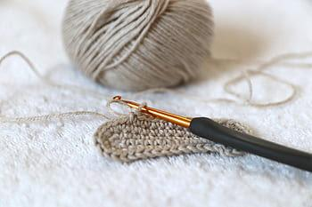 | 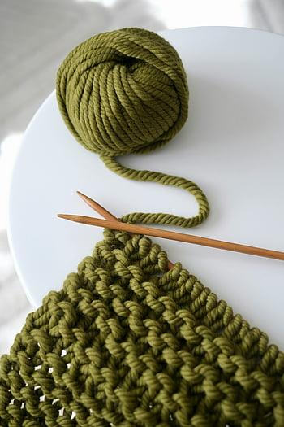

Introduction and Overview
Hello everyone, my name is Lauren Sisco. I graduated high school in 2024, and started at the University of Minnesota Duluth that summer. I graduated with a technical diploma of “Financial Service Customer Representative” from Northwood Technical College, and have certificates in Word, Excel, and PowerPoint. The rest of this website will dig deeper with additional information!
- Hobbies
Page -

Hobbies and Favorite Activities:
- Cooking/Baking - I enjoy sharing my creations with others and making things for people when the opportunity presents itself. I also enjoy eating in general and trying new things. I have been cooking/baking for as long as I can remember, and I’ve always enjoyed trying new kinds of food, either from different cultures, things I wouldn’t have ever thought of, or mixing random things together that I think would go well with one another. Experimenting in the kitchen is fun, interesting, and usually gives you a delicious final product to add to your recipe box.
- Driving - One of my favorite activities is driving at night, so it’s dark, and listening to music. It’s calming and makes one feel like they’re the only person left on the planet, and for me that is fun to experience. If I ever need a time to not stress about anything or have to think about anything else, this is the time to focus on nothing besides the road ahead and the music surrounding me.
- Arts and Crafts - I’m fond of many different types of arts, like pencil/shading work, wood working, sewing, knitting, crocheting, and more. I use this skill to either make things for myself or other people. I have made things for family, friends, myself, companies, to be shipped overseas, etc. I usually try to make something for the people I care about on their birthdays or for Christmas. I like the more personal feel to that portion of their presents, picking the color, style, texture, design, use, etc. while thinking of them to make it as unique and thoughtful to them as I can.
- Nature - I enjoy walking, hiking or anything else that can get me outside and seeing different beautiful sights. I love hiking to a high location to look down at the rolling layers of trees. I like sunsets by any body of water to see the reflections in the water and the colors in the clouds. Even just taking a walk with my dogs is nice, being able to be outside, looking at fields as I pass them by, and being able to share it with my dogs so they get to have new experiences too.
- Watching movies/series from DVDs - I love to rewatch old movie series, especially when they are on DVD. I collect them and don’t see myself stopping that tradition anytime soon. If whatever source I’m trying to watch something on isn’t carrying the movie(s) at the time, then it doesn’t hinder my watching because I have them ready to go at any time. If I don’t know what to watch then I just pick something that sounds good to me from my collection, and I never have to worry about getting bored of them because my series either have 5-8 movies in them to take up a longer time period, or I have enough to search through that no matter what mood I’m in, I can find a movie to watch or put on in the background. My great aunt and uncle like DVDs too, so when I spend time with them I either get to show them a new movie they haven’t seen or they play one I haven’t seen; we also rewatch stuff together and DVDs are a good way to spend time with one another.
Cooking | Baking
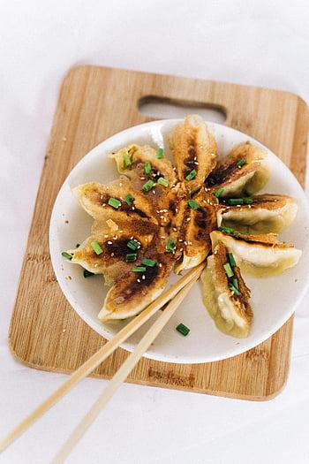 | 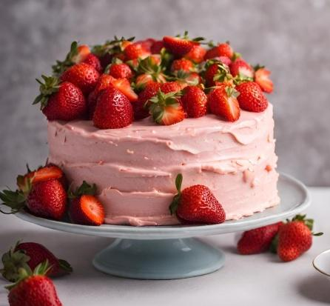

Stories/Experiences:
- There was one particular summer during high school that my aunt and uncle had to leave town for about a week, so I stayed with my aunt’s mother and their dog to take care of them both. I love animals, and I enjoyed my great aunt’s company - she was 98 years old at the time and had a lot of great stories and life experience to share. She was totally self-sufficient, I just cooked and baked for her and played Harry Potter DVDs - an experience mixing multiple favorite activities of mine.
Driving | Crafting
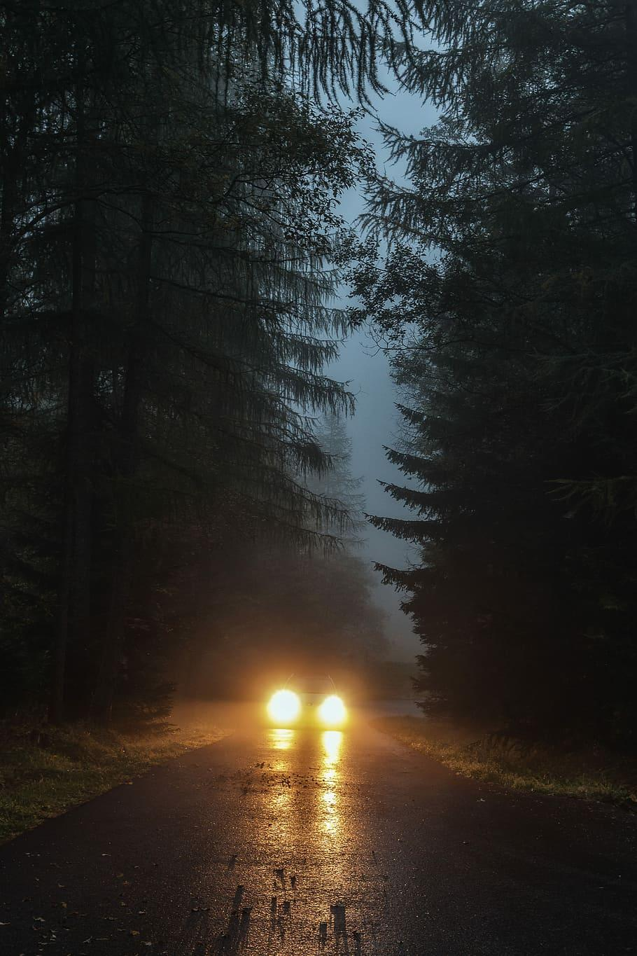 | 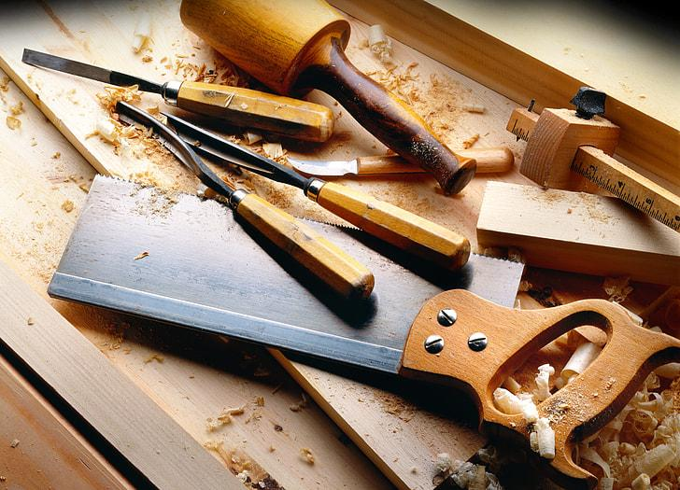
Nature | DVDs
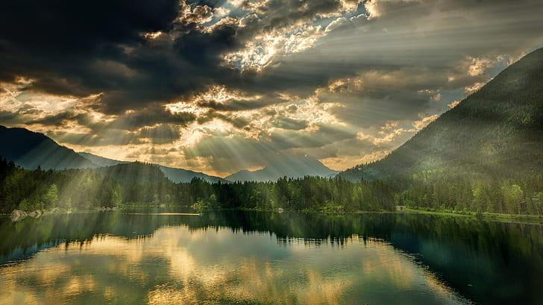 | 

Importance of These Activities:
- Bonding/Connection - Sharing
- Me time/personal pleasure
- Presents: I like to make things for the people I care about
- Entertainment/interest
- Knowledge: I like learning knew things and seeing/doing new experiences

- Discover
Page - (UMD & Duluth)

Why I Chose The University of Minnesota Duluth (UMD):
- Location: A few hours from my house so I can get home without too much effort but I have some distance still.
- Living situation: I wanted to be in an apartment the first year, but many universities don’t allow that - unlike UMD.
- Weather: I wanted to stay somewhere with snow/cooler weather, and the fall is beautiful here.
- Building: I enjoy the fact that the campus is one large building; it’s helpful not needing to identify multiple different buildings, and when it’s really cold/hot out then you don’t need to worry about the weather every hour walking from building to building.
- Size: I’m a fan of the medium sized campus, it’s not too small so I have more opportunities, but not too big because I don’t enjoy people very much.

What I Enjoy From Duluth/The Area:
- Seasons/Weather: I enjoy the cold more than heat, and Duluth is the perfect mix for me. I also enjoy the beautiful range of colors in the fall.
- Activities: There are many events in the area to attend, as well as many outdoor activities to participate in.
- Familiarity: I only live a few hours away from here so I’ve been to this location multiple times already.
- Diversity: There are many different people and cultures here. I live in a small town that’s very strict and “my why or no why” mind set oriented, so it was nice to experience something different and less judgment for people being themselves.

Personal Experiences/Campus Highlights:
- Relationships: I have made and kept good friends here at UMD.
- Proud Experiences: I have remained on the Dean’s List for the duration of my college experience, which is something I’m proud of and strive to continue achieving.
UMD MARKETING VIDEO:
**Insert Video Here**
- Resume
Page -

Resume:
**Insert Resume Here**

PDF Version:
**Insert Download Button Here**

Education/Experience/Skills/

Achievements:
- Technical Diploma: Financial Service Customer Representative - before I graduated high school
- Certifications: Word, Excel, and Powerpoint
- Dean’s List: Throughout college career
- Student of the Month: A few times in high school
- Highest Honors: I graduated with this, it was a program at my high school where the difficulty of your classes were measured in points, and the sum of those numbers multiplied by your GPA would give you a chance to get into an honors section to receive another cord during graduation. Highest Honors was the highest level you could get.
- Career
Interests
Page -

Two Companies I Am Interested In Working For:
- Essentia Health
- Anderson Hager & Moe

Sequential Contact Information:
- EH
  - Corporate Headquarters: 218-786-8376
- AH&M
  - Hayward Location: 715-634-2653
  - Spooner Location: 715-635-8788
  - Rice Lake Location: 715-234-8419
  - Email: info@ahmcpa.com

My Personal Interests In Each Company - Sequentially:
- EH
  - The open position for payroll is a career opportunity that I could see myself pursuing. This is a job I could do from home, which is an aspect I’m interested in. It’s also good experience for future job positions/if I never wanted to move across the country - valuable information no matter where I am, or what I’m doing.
- AH&M
  - I am interested in their Accounting position and/or intern opportunity. The internship would help me grow and learn, and the job positions would give me experience that again, could be taken anywhere at any time. I also live near these locations, so they would be an easy commute for me.

My Qualifications:
- My plan is to major in Accounting and Finance, as well as obtaining a minor in Economics.
- Technical Diploma: Financial Service Customer Representative

Skills/Interests Aligning With Job Positions:
- Certifications: Excel, Word, and PowerPoint
- I’ve always been interested in a financial job.
- Interactive Game Page -

**Insert Interactive Page Featuring A Web-Based Game**

